HACKATHON REPORT
AI Data Analyst
Schema-agnostic natural language analytics with voice: ask, see and hear your data
Hackathon: E-TRONIX'26
Organizer: Department of ECE
Date and Venue: 5-6 October 2026, Sri Shakthi Institute of Engineering and Technology
Team Name: Tech Titans

Name | Role | Email
Nithish T (CSE-C, 1st Year) | Frontend Developer | nithish151226@gmail.com
Nishanth A G (CSE-C, 1st Year) | UI/UX Designer | gokianand064@gmail.com
Lalit Aditya Obuli K (CSE-C, 1st Year) | ML Engineer | obuliadi126128@gmail.com
Manolingesh P (CSE-C, 1st Year) | Backend Developer | manolingesh06@gmail.com
Steffy Camryn (ECE, 2nd Year) | Research | steffycamryn@gmail.com

1. Abstract
Business users hold data in CSV, Excel and JSON files but cannot analyse it without SQL or data-science skills. AI Data Analyst lets anyone upload any such file, ask a question in plain English, and receive the answer, a chart and the SQL proof, all read aloud on request. The system auto-detects the schema, uses an LLM to write read-only SQL, and runs it on DuckDB so the numbers are computed by the database, not guessed by the model. Only a schema profile is sent to the LLM, never raw rows, which protects privacy. Failed queries are retried automatically and unclear questions trigger a clarification request. On upload, an auto dashboard shows KPIs, trends and anomalies.

2. Problem Statement
- Problem (PSA 01, Software): Teams cannot get quick, trustworthy answers from their own files without SQL skills; decisions wait on a few analysts.
- Who is affected: Business users and teams who work with CSV, Excel and JSON data but have no data-science background.
- Why it matters: Faster, evidence-backed decisions. Current tools have these gaps:
- Unknown schema per file, so setup comes first
- Chat tools give answers with no proof, so there is no audit trail
- Raw data sent to AI tools raises privacy risks
- Large files make queries slow

3. Proposed Solution
Overview: Upload a file, chat in plain English, and get the answer, a chart and the SQL proof, read aloud.

Key Features
- Upload CSV, Excel or JSON; schema, types and relationships auto-detected
- Natural-language to read-only SQL, executed in a DuckDB sandbox
- Retry loop for failed queries; asks for clarification when a question is ambiguous
- Answer with the key figure highlighted, plus a chart
- "Show the work": steps, SQL and columns used for every answer
- AI chatbox with text and voice replies (Listen / Stop, voice can be turned off)
- Auto dashboard: KPIs, trend and region charts, insights with method and confidence
- Secure sign-in and sign-up with inline field validation
Unique value: Every answer comes with proof, and only a schema profile ever reaches the LLM, so it is private, auditable and works without any SQL knowledge.

4. Technical Approach
Architecture (flow): Input Block (Upload panel, AI chatbox) → Processing Block (Ingestion → NL to SQL → DuckDB sandbox → Insight engine) → Output Block (Answer + chart, SQL + reasoning, Auto dashboard, Voice reply). Storage layer: Parquet files, metadata and query cache with per-session isolation, read-only SQL and an audit trail.
Layer | Technology
Backend | Python, FastAPI
Query engine | DuckDB with Parquet storage
LLM | Anthropic API (schema profile only)
Query validation | sqlglot SQL parser
Charts / Frontend | Chart.js, web interface
Voice | Web Speech API (text-to-speech)

Data flow: File upload → ingestion and schema profiling → plain-English question → LLM writes SQL → validation (read-only) → DuckDB runs the query → insight engine computes stats and charts → answer, chart, SQL proof and voice reply.
Design trade-offs: The LLM adds latency and cost per question, so repeated queries are cached. Single-node DuckDB limits scale to tens of millions of rows. Ambiguous questions can be misread, so the system asks for clarification. Voice quality depends on the device's speech engine.

5. Implementation

Completed During the Hackathon
- Secure login and sign-up screen
- File ingestion with schema detection
- AI chatbox with NL-to-SQL, DuckDB execution and highlighted answers
- Voice replies using the Web Speech API
- Auto dashboard with KPIs, monthly revenue trend, revenue by region and insights

Links
- GitHub: https://github.com/manolingesh06-glitch/tech-titans
- Live Demo: [link]
- Demo Video: [link]

Challenges and Solutions
Challenge | Solution
Unknown schema for every uploaded file | Automatic schema, type and relationship profiling on ingestion
Privacy of business data | Only the schema profile is sent to the LLM, never raw rows
Wrong or unsafe generated SQL | Read-only queries, sqlglot validation and a retry loop
Slow queries on large files | DuckDB with Parquet and a query cache
Answers that cannot be trusted | SQL, steps and columns shown with every answer

6. Results and Impact
Prototype status: Working prototype with login, chatbox, voice and auto dashboard.
Demo result: On a sample file (sales_2025.csv, 12,480 rows) the system answered "Which region earns the most?" with "North earns the most at 482k, about 29% of all revenue; West is the lowest at 312k", with the SQL shown. The auto dashboard reported total revenue of $1.63M (up 75% since January), 12,480 orders, an average order value of $131 and 14 unusual orders flagged.
Metrics: [Add measured response time / accuracy, if tested]
Expected impact: Non-technical users get fast, verifiable answers, reducing dependence on analysts and speeding up decisions.

7. Feasibility and Business Model
Target market: Small and medium businesses, business and operations teams, students and educational institutions.
Revenue: [Free tier plus paid plans for larger files and teams; adjust as decided]
Scalability: Modular blocks; DuckDB handles millions of rows on one node, and the design can move to distributed engines later.

8. Limitations and Future Scope

Limitations
- Single-node DuckDB limits scale to tens of millions of rows
- Each question adds LLM latency and cost (reduced by caching)
- Ambiguous questions may be misread; clarification is requested
- Voice quality depends on the device's speech engine

Future Plans
- Support for databases and larger data via distributed engines
- Voice input and more languages
- Shareable dashboards and scheduled reports
- Fine-tuned query accuracy using Spider and BIRD style benchmarks

9. Team Contributions
Member | Role | Contribution
Nithish T | Frontend Developer | Login page, AI chatbox, auto dashboard and charts (Chart.js), frontend integration
Nishanth A G | UI/UX Designer | Interface design, user flow, layout of chatbox and dashboard
Lalit Aditya Obuli K | ML Engineer | NL-to-SQL prompts using schema profile, retry loop, clarification logic, insight engine
Manolingesh P | Backend Developer | FastAPI backend, file ingestion, schema detection, DuckDB and Parquet storage, query validation
Steffy Camryn | Research | Problem research, benchmarks and references, report and documentation

10. Learnings and Experience
- Learned how to combine LLMs with a deterministic engine (DuckDB) so results can be trusted
- Learned query validation, privacy-aware design and prompt design with schema profiles
- Teamwork across first-year CSE and second-year ECE members
- Next time, we would plan testing and user feedback earlier

11. Conclusion
AI Data Analyst lets anyone ask, see and hear answers from their own data, with the SQL proof behind every figure. By keeping raw data private and computing results in a sandboxed database, it makes data analysis accessible, auditable and fast.

12. References and Appendix
- DuckDB documentation: duckdb.org/docs
- FastAPI: fastapi.tiangolo.com
- Chart.js: www.chartjs.org/docs
- Spider benchmark (Yu et al., 2018): arxiv.org/abs/1809.08887
- BIRD benchmark (Li et al., 2023): arxiv.org/abs/2305.03111
- DIN-SQL (Pourreza and Rafiei, 2023): arxiv.org/abs/2304.11015
- sqlglot SQL parser: github.com/tobymao/sqlglot
- Anthropic API documentation: docs.anthropic.com
- Web Speech API, MDN: developer.mozilla.org/en-US/docs/Web/API/Web_Speech_API
- Appendix: UI screenshots, pitch deck, certificate, demo video

Team at Work
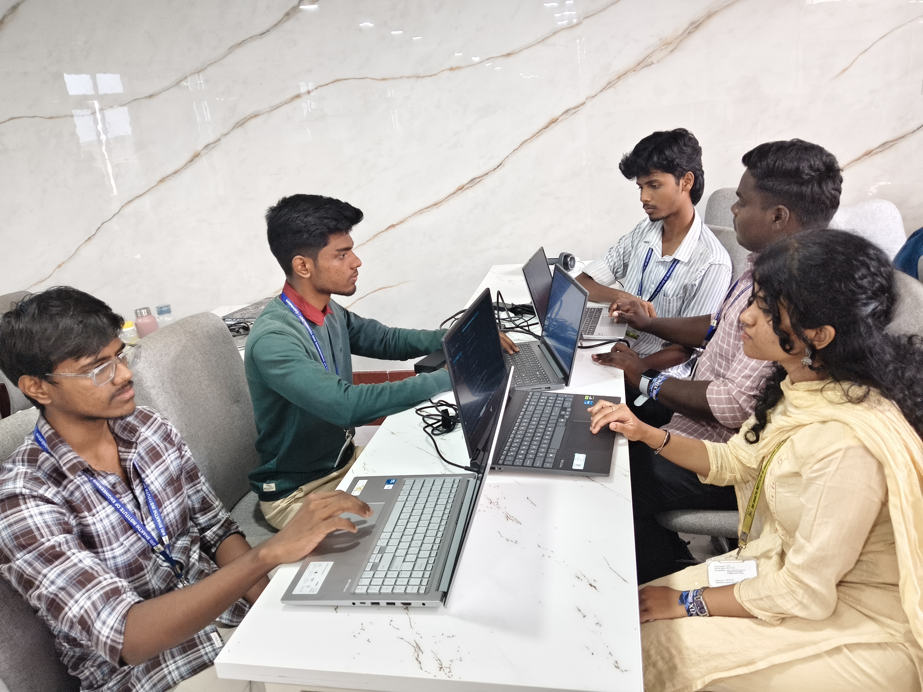
Team Tech Titans working during E-TRONIX'26, Sri Shakthi Institute of Engineering and Technology

